Patient Name:



`r first_name`

`r last_name`

Date of Birth:

`r dob`

February 24, 2021

**`r first_name_physician3`**

`r last_name_physician3`

**, MD**

`r street_address_physician3`

**`r city_physician3`**

**,**

`r state_physician3`

**`r zip_physician3`**

RE: **Clinical Research Visit Results** **for**

`r first_name`

`r last_name`

, DOB

`r dob`

Dear Dr.

`r last_name_physician3`

,

Your patient,

`r first_name`

`r last_name`

, was a recent research participant on

`r fu_date_7yr`

in the Vanderbilt Memory & Alzheimer’s Center’s *Memory & Aging Project*. This study, funded by the National Institutes of Health and Alzheimer’s Association,investigates the relationship between heart health and brain aging in older adults. The study visit involves a fasting blood draw, neuropsychological evaluation, echocardiogram, and cardiac MRI at the Vanderbilt University Medical Center.

Participants may elect to have their laboratory, neuropsychological, and echocardiogram results released to their treating physician(s).

`r salutation`

`r last_name`

has provided permission for us to release

`r pronoun_poss`

results to you. Enclosed, you will find a copy of the **Release of Medical Information Form** signed by your patient. For your records, please find a summary of

`r salutation`

`r last_name`

’s laboratory, neuropsychological, and heart test results from

`r pronoun_poss`

initial enrollment visit on

`r enroll_date`

,

`r pronoun_poss`

18-month follow-up visit on

fu_date_18mos

,

`r pronoun_poss`

36-month follow-up visit on

`r fu_date_36mos`

,

`r pronoun_poss`

60-month follow-up visit on

`r fu_date_60mos`

, and

`r pronoun_poss`

recent 7-year follow-up visit on

`r fu_date_7yr`

summarized below:

**Vital Signs**

*These values are recommended by Vanderbilt University Medical Center; **Bold**=outside range

**Fasting Blood Work Results**

*These values are recommended by Vanderbilt University Medical Center; **Bold**=outside range

**Neuropsychological Test Results**

During

`r salutation`

`r last_name`

’s visit,

`r pronoun`

completed a series of paper and pencil tests and puzzles that assess different cognitive activities, such as memory, language, attention, planning, multi-tasking, and spatial abilities.

`r pronoun_poss_cap`

performance was compared to other

`r gender_cap`

who are of

`r pronoun_poss`

same age and similar education background. Below is a summary of results:

**Heart Test Results**

`r salutation`

`r last_name`

completed heart testing, which was read by a board-certified cardiologist.

`r pronoun_poss_cap`

**enrollment visit results on**

`r enroll_date`

were as follows:

1. Normal left ventricular systolic and diastolic function  
2. Normal left ventricular chamber size; no left ventricular hypertrophy  
3. Normal valvular function  
4. No aortic dilatation or aortic plaque

`r pronoun_poss_cap`

**18-month visit results on**

`r fu_date_18mos`

were as follows:

1. Normal left ventricular systolic function; normal diastolic function
2. Small left ventricular chamber size; no LV hypertrophy
3. No significant valvular abnormality
4. Normal aortic dimensions; no aortic plaque

`r pronoun_poss_cap`

**36-month visit results on**

`r fu_date_36mos`

were as follows:

1. Normal left ventricular systolic function; normal diastolic function
2. Normal left ventricular chamber size
3. Normal right ventricular size and systolic function
4. No significant valvular abnormality

`r pronoun_poss_cap`

**60-month visit results on**

`r fu_date_60mos`

were as follows:

* 1. Normal left ventricular diastolic function
  2. No significant valvular abnormality

`r pronoun_poss_cap`

**current results on**

`r fu_date_7yr`

were as follows:

1. Normal left ventricular diastolic function
2. No significant valvular abnormality

Please note that while we provide the same results summary listed above to our research participants, we *do not* discuss clinical implications of the blood work or cardiac imaging results with our research participants. Our study doctors only offer brief feedback about the neuropsychological test results. We encourage participants to discuss the laboratory and cardiac imaging results with their treating physicians.

Should you have any questions regarding the content of this letter, please feel free to contact the study team (615-347-6937). Also, if you have additional older adult patients in your practice who might benefit from a memory diagnostic workup, please have them contact our clinic to schedule an appointment (615-936-0060). We have enclosed copies of our memory loss workup brochures for more information.

Sincerely,

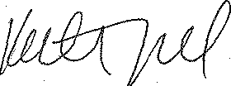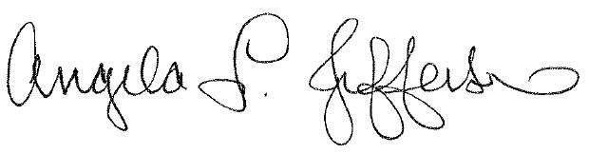

Angela L. Jefferson, PhD Katherine A. Gifford, PsyD

Professor of Neurology Assistant Professor of Neurology

Director, Vanderbilt Memory & Alzheimer’s Center Neuropsychology Co-Investigator

Principal Investigator, Memory & Aging Project Memory & Aging Project

[angela.jefferson@vumc.org](mailto:angela.jefferson@vumc.org) [katie.gifford@vumc.org](mailto:katie.gifford@vumc.org)

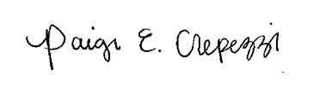

Paige E. Crepezzi, BSN, RN

Research Nurse Specialist

Memory & Aging Project

[paige.e.crepezzi@vumc.org](mailto:paige.e.crepezzi@vumc.org)